Group: 6

Members: Landon Petzel, James Gangavarapu, Jarmal Gardner, Ejiro Imarah

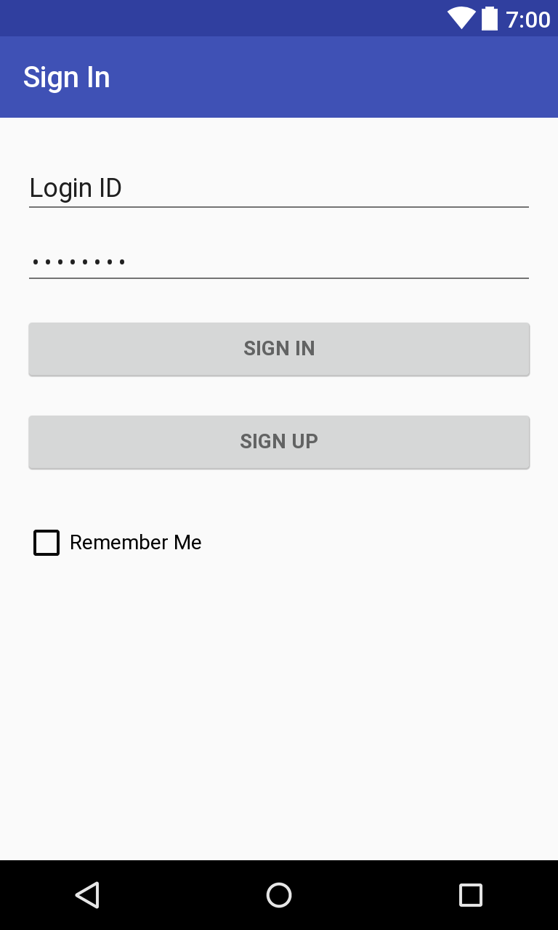**Storyboard**

**Login Page**

- Displays item boxes for the user to input

their username and password. There is also

an option to sign up and create an account.

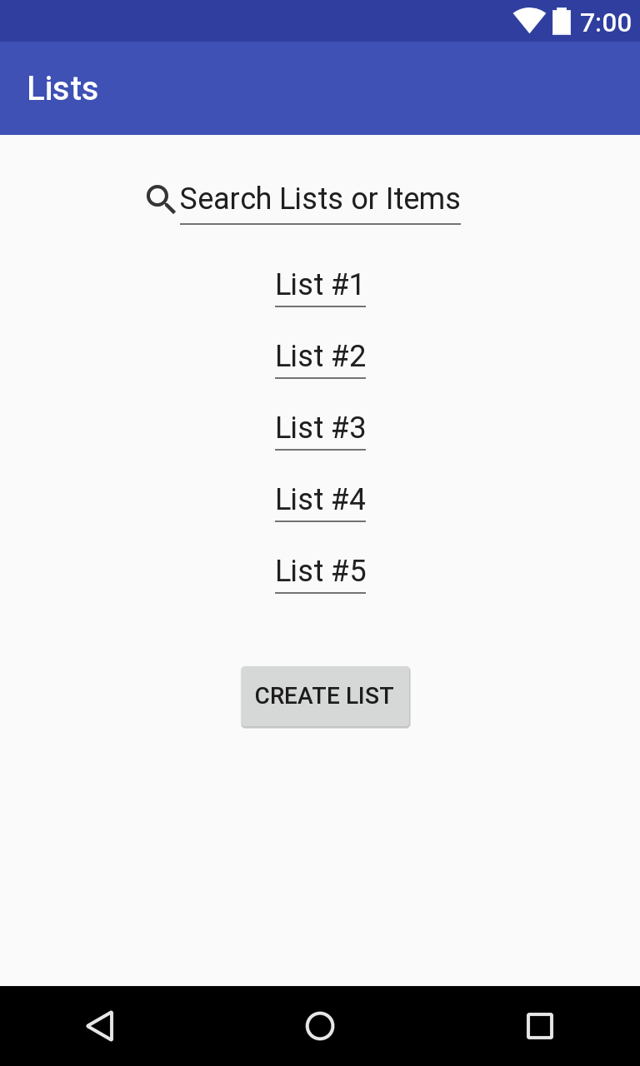

**List Page**

- The list page displays all the lists that

the user is currently in. It also has an

option to create a new list or search

for an entered list or item.

**Individual List Page**

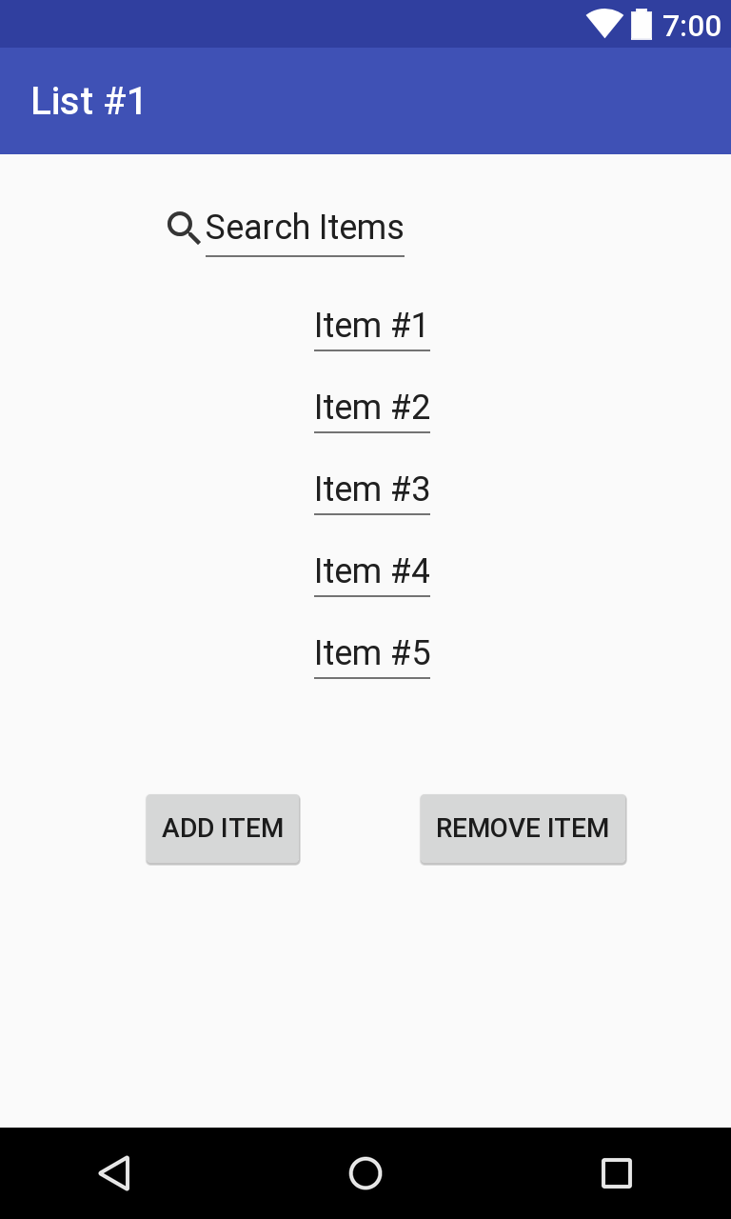-This page shows all the items in the list. It has

the options to add an item and remove an item.

There is also a search box to look up an item in the list.

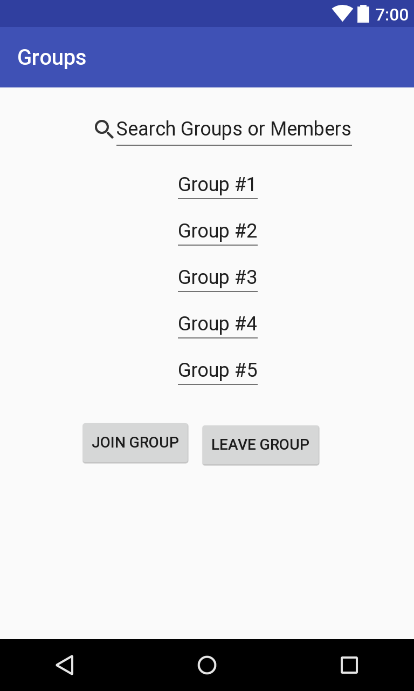 **Groups Page**

- This page displays all the groups the user

is in. It has options to search for a group,

join a group, and leave a group.

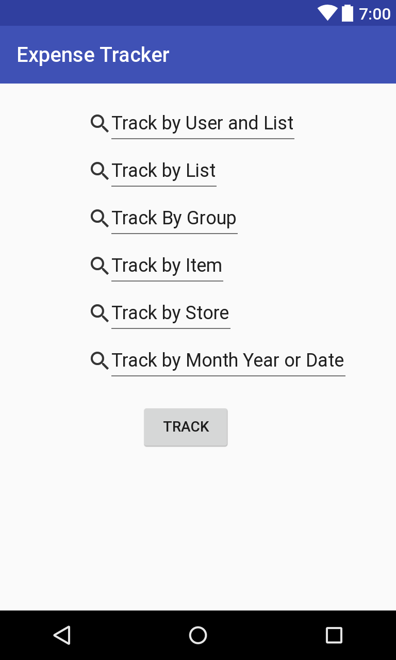

**Expense Tracker Page**

- Displays a list of different search boxes to keep

track of expenses in various ways.